Unit 1: Physical Geography
Types of Maps Activity
Map Type  *Copy & paste a picture below* | Definition
1. Political  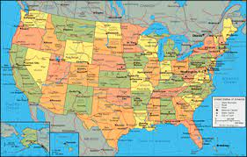 | A map that shows the borders of countries, states and their cities/capitals, as well as counties.
2. Physical  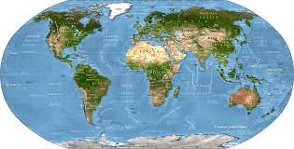 | A map that shows physical natural locations and landmarks.
3. Topographic 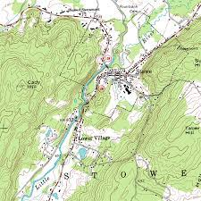 | A map that shows land features, it includes roads, plans of towns, and contour lines.
4. Climate 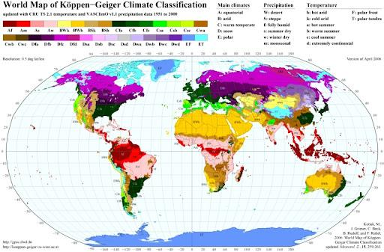 | A map that shows the average of a certain time’s climate, in an area.
5. Choropleth 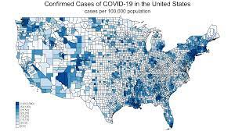 | A map that shows the averages of a person, place or thing in an area using color or symbols.
6. Road  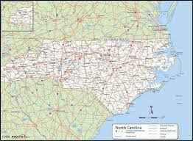 | A map that shows the road/layout of a place that was designed for drivers.
7. Thematic 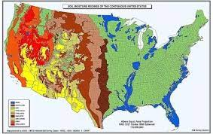 | A map that shows a pattern of something that cannot be seen on a regular map, such as temperature, language, or population.
8. Cartogram  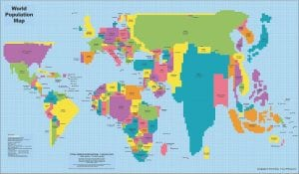 | A map that has a changed shape to show the level of a chosen variable in that region.
9. Dot Map  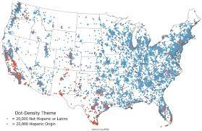 | A map that visually shows the occurrence of something in a region using a dot.
10. Isoline  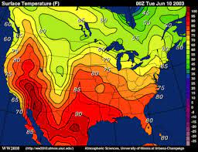 | A map that presents numerical data that is linked together (relationship).

