Tips for Writing FRQ’s

- Free Response Questions (FRQ’s) are seen as draft essays, not as polished essays on the AP exam. This is the case because of the time constraint you will face in trying to write 3 of them in 75 minutes. Remember, there are no DBQ’s on the APHG Exam.

- Do not rewrite the question in your response and make sure you answer what the question asks! NO THESIS STATEMENTS, INTRODUCTIONS OR CONCLUSIONS. They will not be scored!

- Each FRQ will have 7 Parts (A-G) and will take one of three forms; 1. Basic Question with No Stimulus, 2. Question with One Stimulus, or 3. Question with Two Stimuli.
The stimulus part of the question will be a map, graph, chart, or data table of some kind that you will be expected to interpret, and use to answer the questions. Keep in mind that you will also have to incorporate other information too! Don’t just write about the information in the stimulus!

- Follow the basic format of, Answer, Give a Specific Example, then Explain your Example. This will ensure that you fully answer each part of the question.

- Try to avoid writing essays where you “dump” or empty your brain of everything you can think of onto the paper. However, you should try to answer the 5 W’s (Who, What, When, Where, Why, and How) in your answer in order to make sure that you thoroughly cover the topic.

- Remember to try and integrate Geographic Themes in your response. For example, using a point from several different units of study in your answer. You should go through Each of the Units (Intro to Geography, Population & Migration, Culture, Political Geography, Agriculture, Economic/Industrial, Urban Geography) in your mind when answering the question and ask yourself how this question might relate to each one. This will ensure that you write a rich and thorough answer and that you demonstrate a strong understanding of the course.

- Use Key Terms from Human Geography and try to incorporate information and your knowledge of other content areas, current events, and your own life when appropriate.

- Answer the question in the same format that it is written. Answer part A, then B, and then C, etc.

- You can sometimes “explain” in a sentence or two. You should not belabor a point. Be direct and use specific evidence to support your argument.

- Only answer what you are being asked to answer, but BE SPECIFIC! It is critical that you have supporting evidence in your response! Typically, scorers are instructed to ONLY accept your first example or how many you are asked for so try to put your most solid answers as your first responses. However, pay attention to how many examples the question is looking for so that you can get all of the points.

- OUTLINING the questions will help you tremendously! As soon as you get the FRQ’s, spend a couple of minutes outlining the main points for your answer right on the question sheet. This way, when you go to write your full response, you will have a baseline of information and important points to send you on your way. Those who have done this in the past have told me it has really helped them be successful on the exam.

- Answer the question you think is the easiest first; then go onto the next easiest, etc… This way, you leave the hardest one for the end when you have more time to answer. It doesn’t matter if the questions are in order when you write them in your answer booklet.

Key Words to understand when answering the FRQ’s
Compare/Contrast: Provide a description or explanation of similarities and/or differences.
Define: Provide a specific meaning for a word or concept.
Describe: Provide the relevant characteristics of a specified topic.
Discuss: give SPECIFIC EXAMPLES that support/back your specific points
Explain: Provide information about how or why a relationship, process, pattern, position, or outcome occurs, using evidence and/or reasoning. Clarify your points; provide the causes or reasons for something; make known in detail; tell the meaning of.
Identify: Indicate or provide information about a specified topic, without elaboration or explanation.
Analyze: Determine the component parts; examine the nature and relationship.
Assess/Evaluate: Judge the value or character of something; evaluate the positive and negative points; give an opinion regarding the value of something.

The following are Two Examples Free-response Questions Found on the Exam
Note that on the actual AP Exam, there will be three free-response questions.

1. In most countries, the concept of the state as a political unit is subject to the tensions
between centrifugal and centripetal forces. Governments are often challenged by the
devolutionary factors that challenge state sovereignty.

(A) Define the concept of the multinational state.
(B) Explain how ethnicity can be a factor that leads to the devolution of a state.
(C) Explain how communication technology plays an important role in the goals of
devolutionary groups and democracy movements.
(D) Explain the limitations of communication technology in furthering the goals of
devolutionary groups and democracy movements.
(E) Describe ONE centripetal force that governments use to promote the state as a
nation.
(F) Explain how uneven development within a state can act as a centrifugal force.
(G) For a multinational state facing the realities of devolution, explain why a
government would choose to create an autonomous region or choose to
maintain a unitary state.

2. NATIONAL CAPITAL TERRITORY OF DELHI, INDIA, POPULATION CHANGE
Census Year | 1991 | 2001 | 2011
Total population | 9,420,644 | 13,850,507 | 16,787,941
Population density per square mile | 17,771 | 26,128 | 31,669

COMMUTERS IN DELHI, INDIA
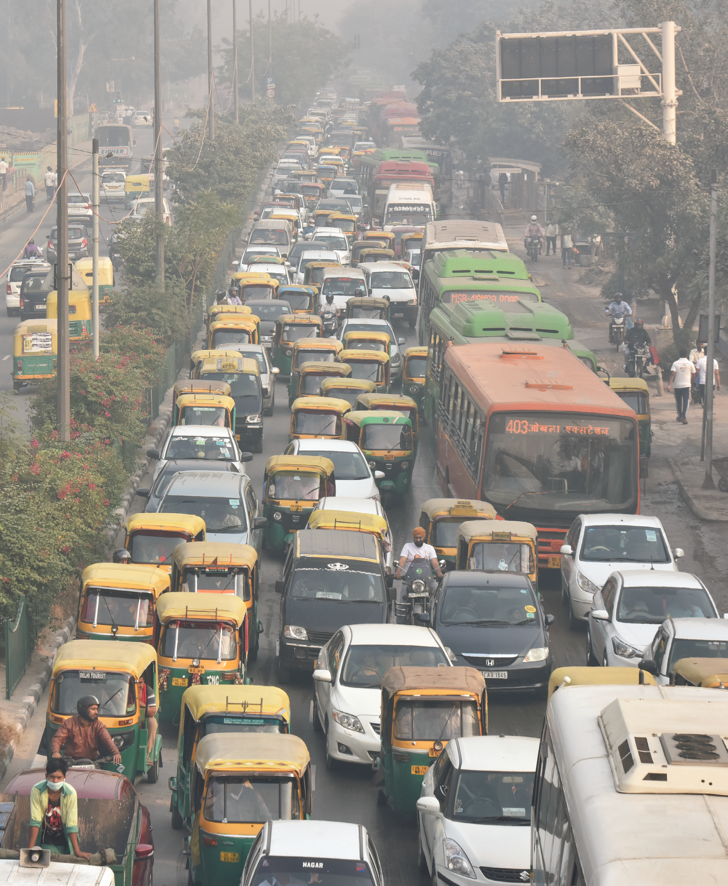

The National Capital Territory of Delhi, India, includes the old city of Delhi; the national capital city of New Delhi; and surrounding districts, where much of the city's population resides.

(A) Describe the data in the table that classifies Delhi as a megacity.
(B) Describe a pull factor that has contributed to Delhi’s total population change
over time.
(C) Explain how local housing development has contributed to the change in Delhi’s
population density, as shown in the data table.
(D) Given Delhi’s population density, describe a challenge related to urban
infrastructure that the city’s government is likely to face.
(E) Explain the challenge to Delhi’s local environmental sustainability that is shown
in the photograph.
(F) Explain the degree to which India’s level of economic development as a country
contributes to Delhi’s local challenges to environmental sustainability.
(G) Explain a possible solution to the challenge of environmental sustainability that
is shown in the photograph.

