AP Exam Models Review

Unit 1: Physical Geography

Latitude & Longitude
The Prime Meridian lies at 0 degrees Longitude and the Antipodal Meridian, a.k.a the International Dateline lies at 180 degrees Longitude. The Equator marks 0 degrees latitude. Every point on Earth has unique coordinates using a geographic grid of parallels and meridians.

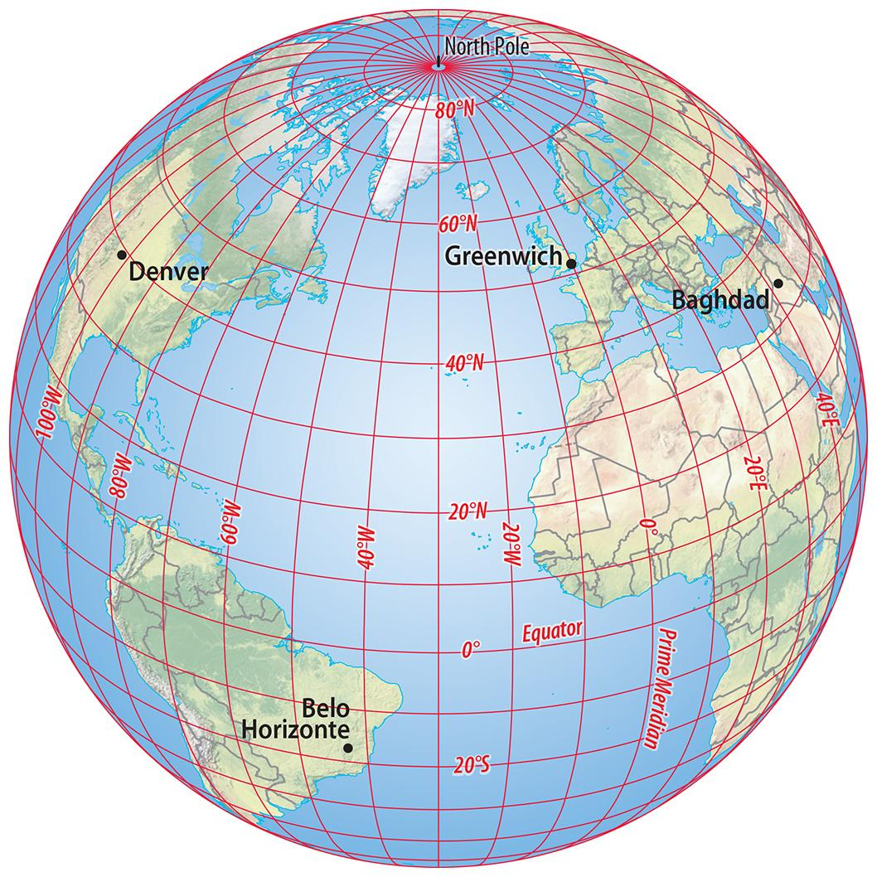

The Tropics
The Tropic of Cancer and the Tropic of Capricorn are located at 23.5 degrees North and South of the Equator. The hot climate region that lies between them is known as the Tropics.

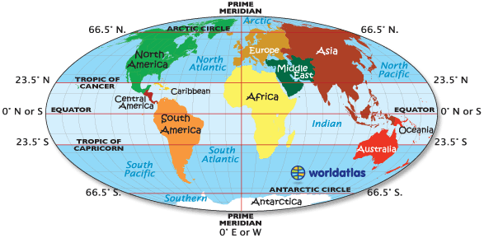
Time Zones
Lines of Longitude are the basis for calculating time. Time zones roughly follow lines of longitude every 15 degrees but vary for political and functional reasons.

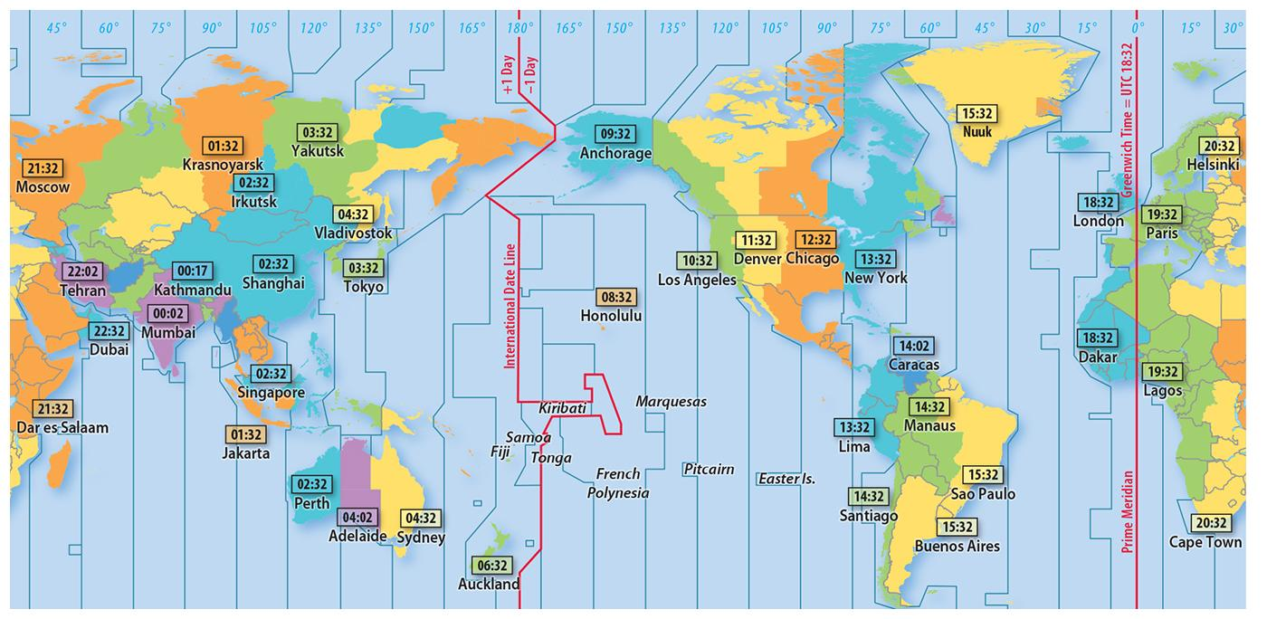

Map Projections
There are 3 general classes of map projections: Conic, Cylindrical, and Planar (Azimuthal). There is also a fourth class, False Cylindrical, which is oval-shaped.

Conic
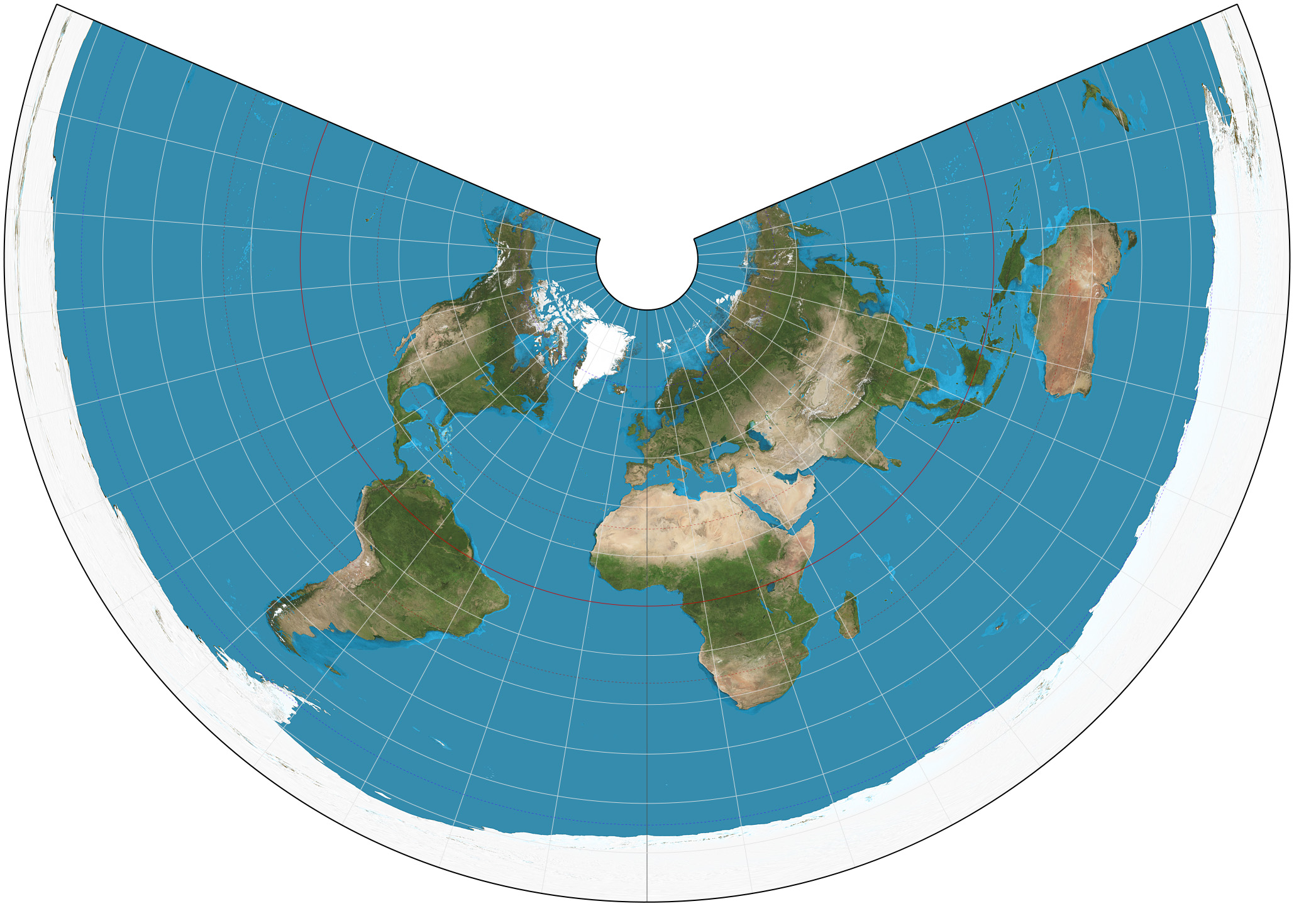

Cylindrical
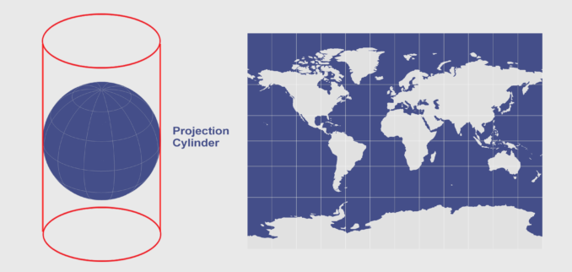

Planar
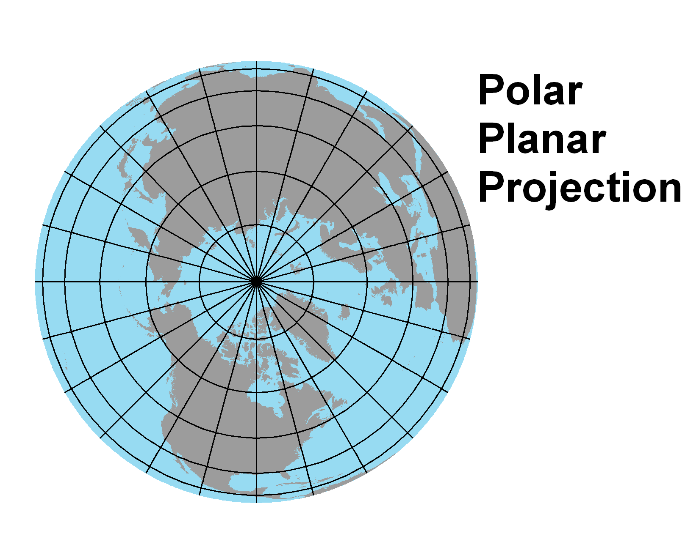

The Robinson Projection is a map projection of a world map which shows the entire world at once. It was specifically created in an attempt to find a good compromise to the problem of readily showing the whole globe as a flat image.
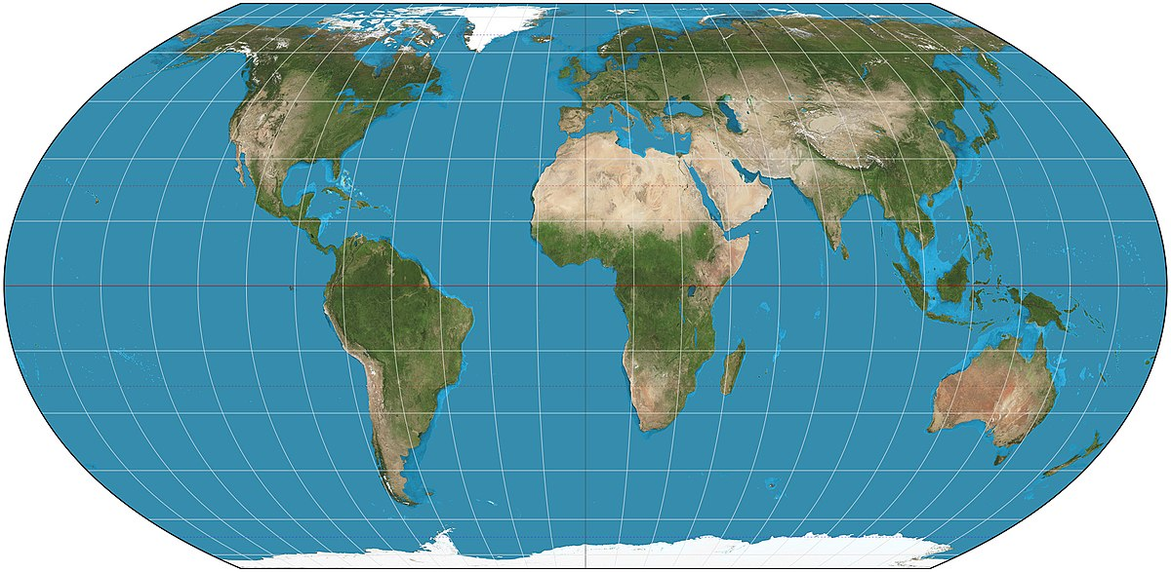

The Mercator Projection minimizes the distortion of shape and direction but grossly distorts area toward the poles, making high latitude places look much larger than they actually are.

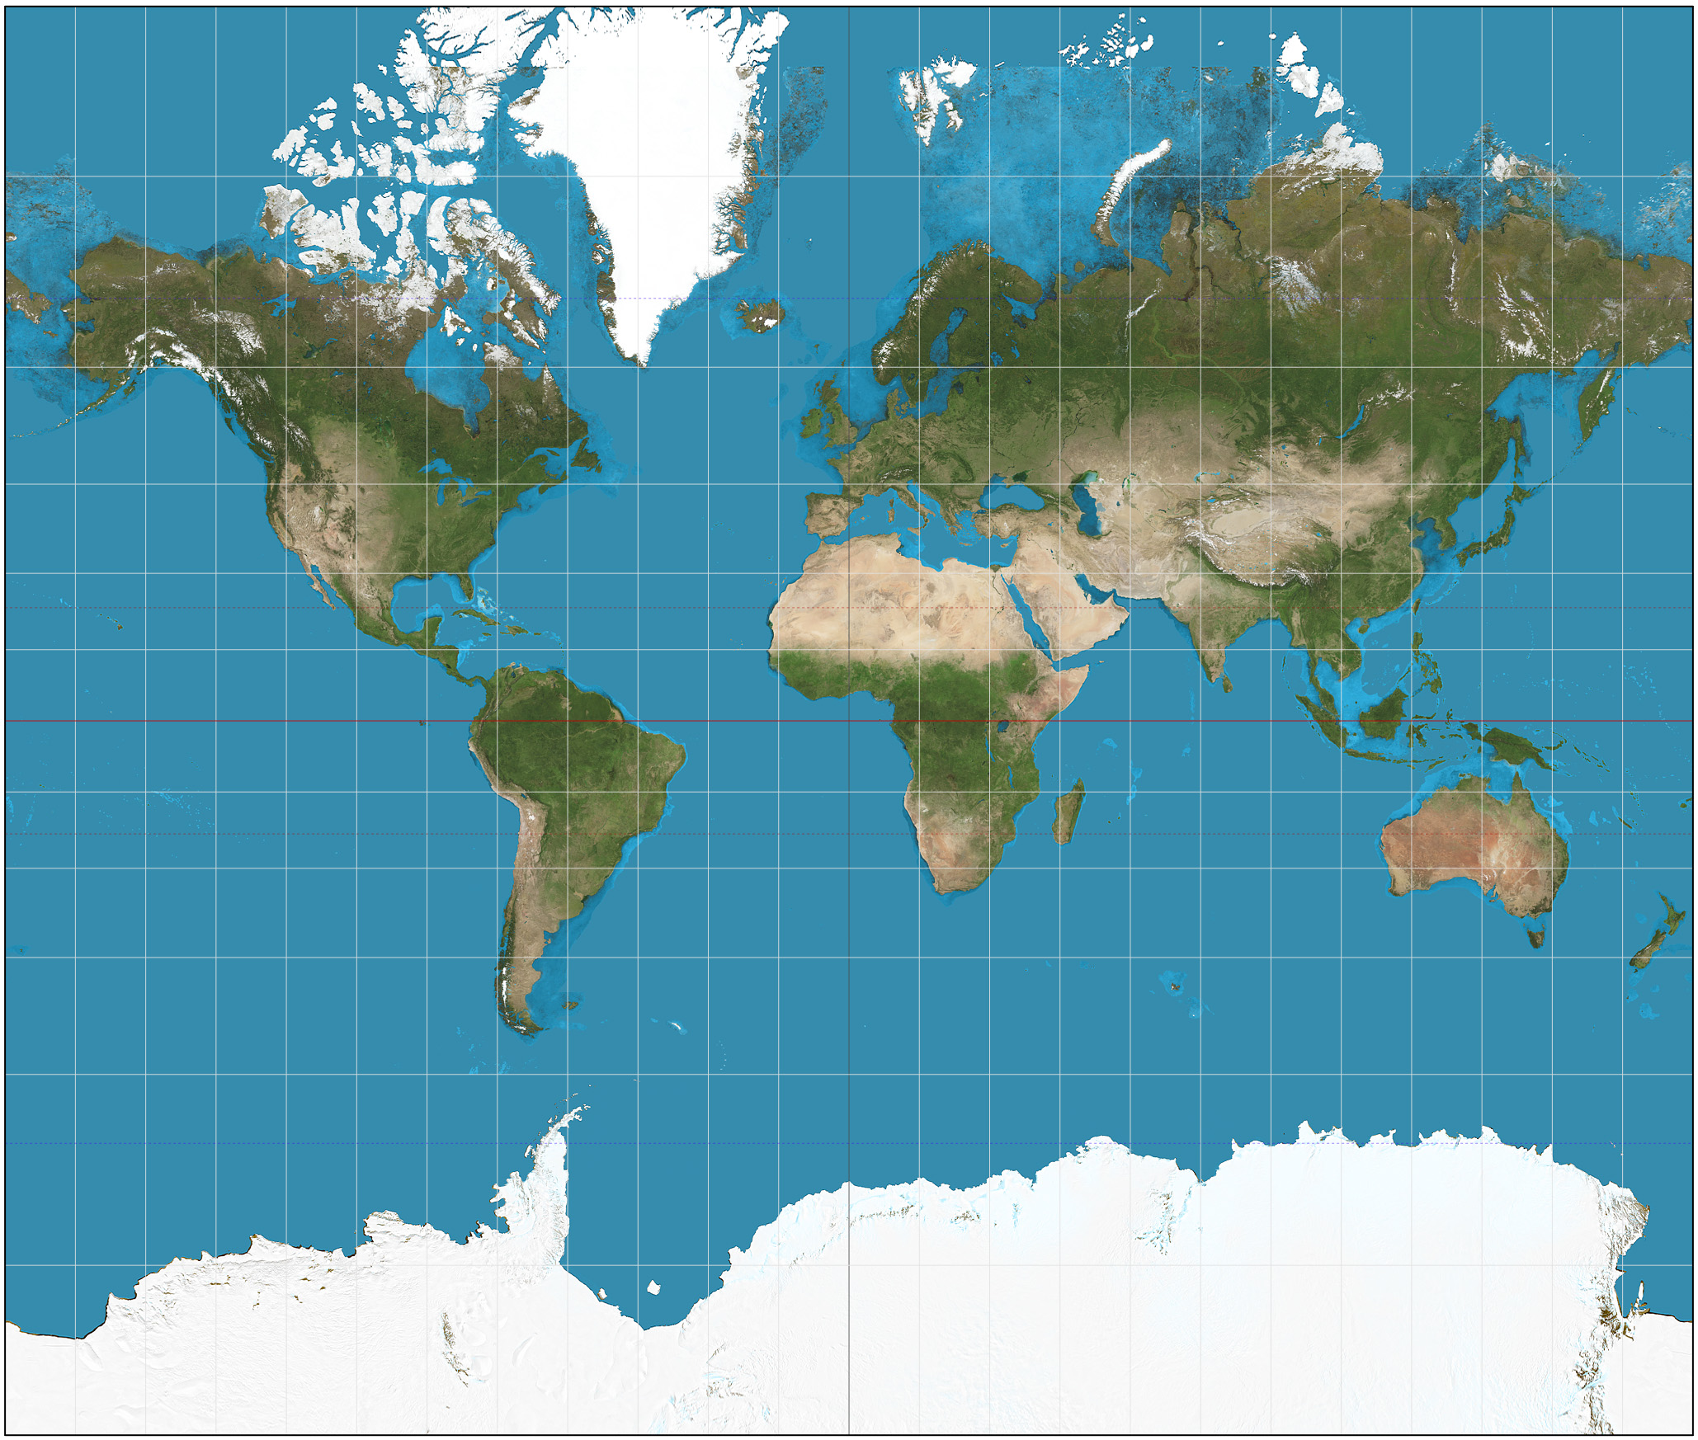

The interrupted Goode Homolosine Projection, often referred to as the “orange peel map” is good at mapping human phenomena across space.

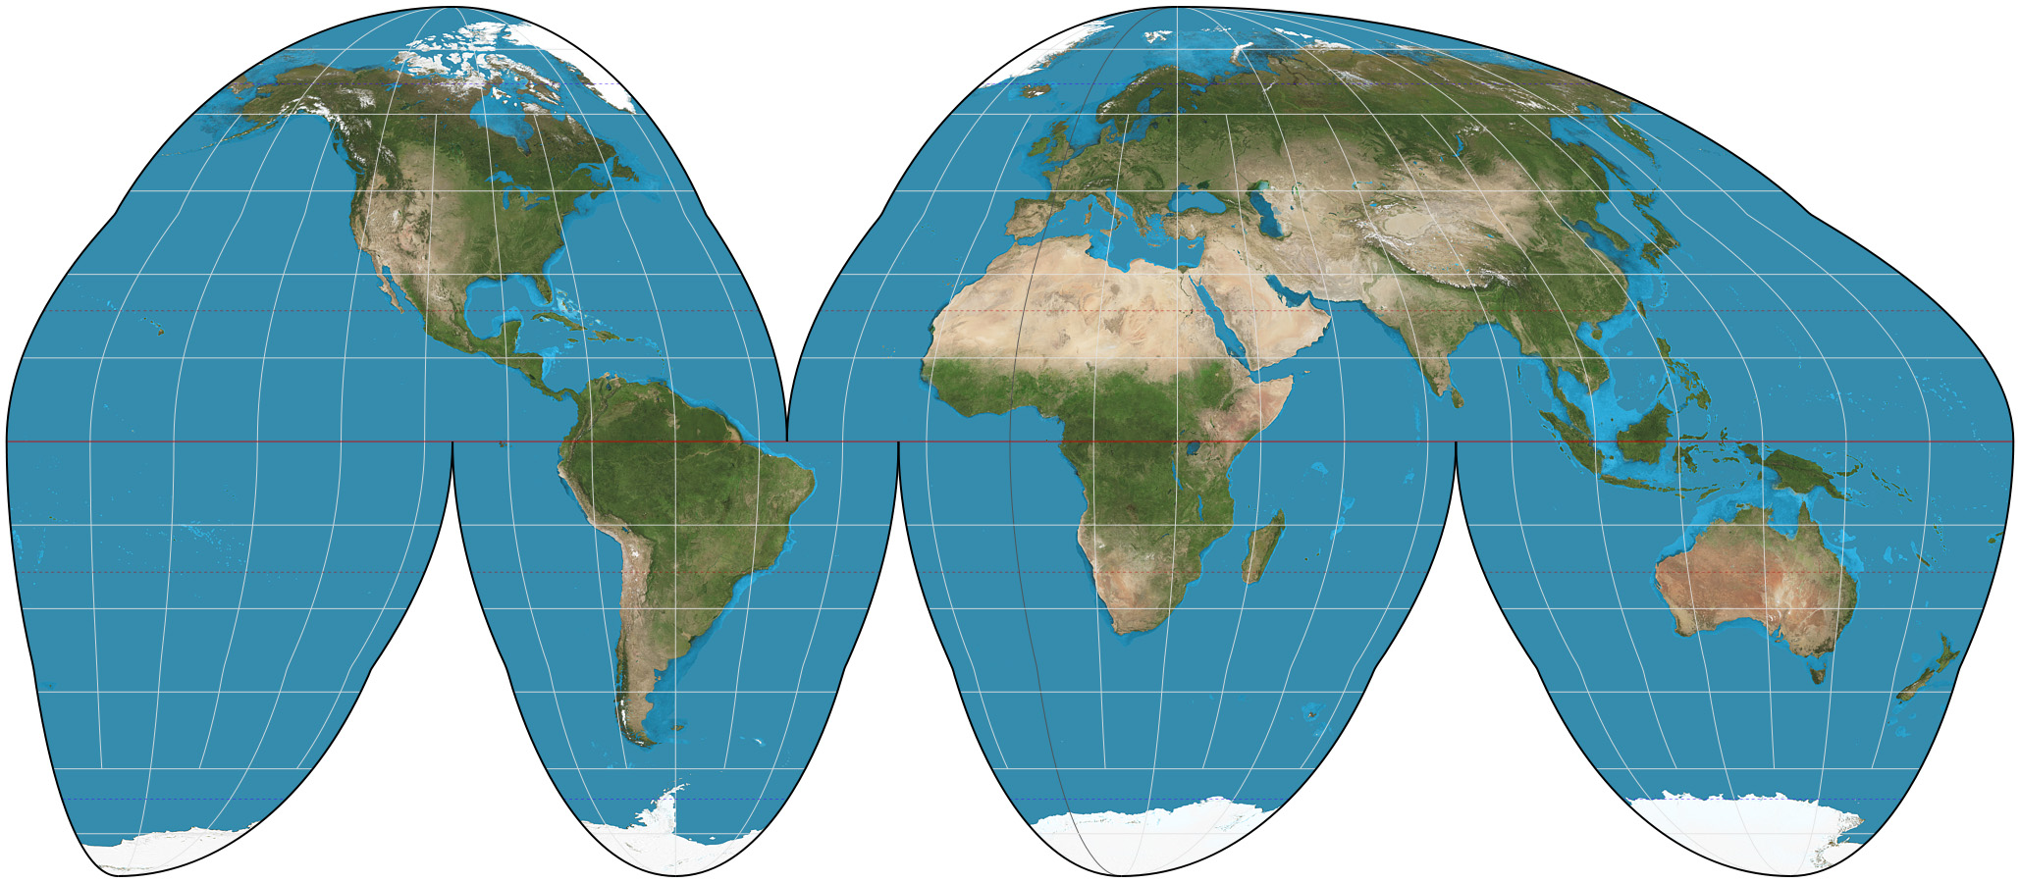

Koppen Climate System

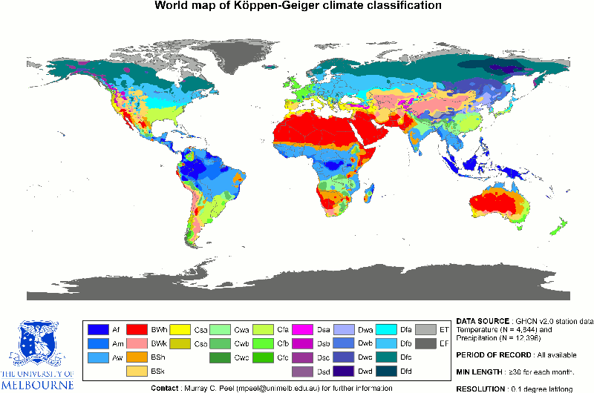
Köppen system contains up to three levels of sorting based primarily on temperature and precipitation information.
A - Tropical Moist Climates: These are very warm climates found in the tropics that experience high quantities of precipitation. The primary distinguishing characteristic of these climates is all months have average temperatures above 18°C (64°F).
B - Dry Climates: These are climates that experience little precipitation during most of the year. Further, potential losses of water from evaporation and transpiration greatly exceed atmospheric input.
C - Moist Mid-latitude Climates with Mild Winters: In these climates, summer temperatures are warm to hot and winters are mild. The primary distinguishing characteristic of these climates is the coldest month has an average temperature between 18°C (64°F) and -3°C (27°F).
D - Moist Mid-Latitude Climates with Cold Winters: In these climates, summer temperatures are warm and winters are cold. The primary distinguishing characteristic of these climates is the average temperature of warmest month exceeds 10°C (50°F), and average temperature of coldest is below -3°C (27°F).
E - Polar Climates: These climates have very cold winters and summers, with no real summer season. The primary distinguishing characteristic of these climates is the warmest month has an average temperature below 10°C (50°F).
H - Highland Climates: These are climates that are strongly influenced by the effects of altitude. As a result, the climate of such locations is rather different from places with low elevations at similar latitudes.

Unit 2: Population and Migration

Population Pyramids
Population pyramids are used by demographers as a tool for understanding the makeup of a given population, whether a city, country, region, or the world. ... A Population Pyramid is a graph that shows the age-sex distribution of a given population. It a graphic profile of the population's residents.

3 Main Shapes of Pyramids
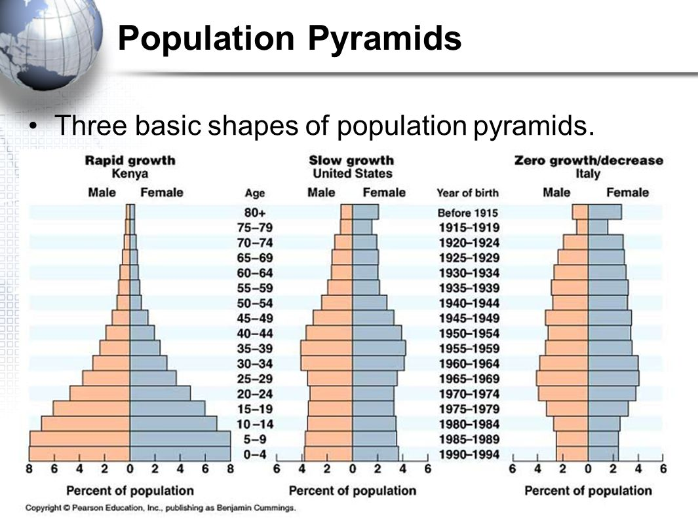

Demographic Transition Model
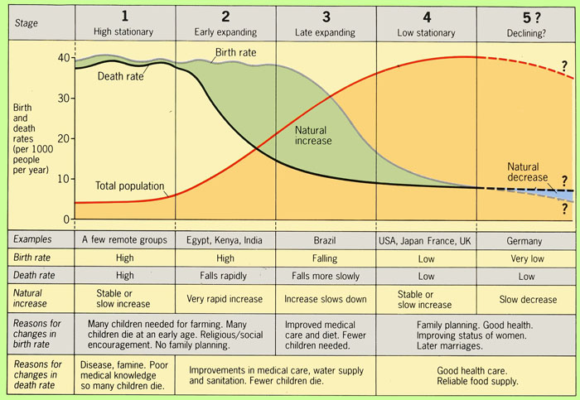

Stage 1=Low growth Stage 2=High Growth
Stage 3=Moderate Growth Stage 4=Low Growth.

A country moves from high birth and death rates to low birth and death rates through time.

Epidemiologic Transition Model
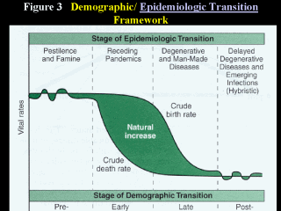

5 Stages of Epidemiologic Transition
Stage 1: Pestilence and Famine (High CDR)
- infectious and parasitic diseases, accidents, animal attacks, violence, Black Plague

Stage 2: Receding Pandemics (Rapidly Declining CDR)
- improved sanitation, nutrition, and medicine during the Industrial Revolution reduced the spread of infectious diseases, although cholera was widespread

Stage 3: Degenerative Diseases (Moderately Declining CDR)
- decrease in infectious diseases and an increase in diseases such as heart disease, cancer, diabetes, obesity

Stage 4: Delayed Degenerative Diseases (Low But Increasing CDR)
- delayed degenerative diseases, advancements in medicine, i.e. cancer treatments, bypasses, changes in diet, reduced use of tobacco/alcohol, more exercise

Stage 5: The Return of Infectious Diseases

Wilbur Zelinsky’s Migration Transition Model
- Geographer Wilbur Zelinsky determined that migration transition follows a similar pattern to that of the DTM. (Ex. Countries in Stage 2 of the DTM model have more migrants than those in Stage 3, 4, or 5.)

Ravenstein’s “Laws” of Migration
1. Every migration flow generates a return of counter migration.
2. Most migrants move a short distance.
3. Migrants who move longer distance tend to move to urban areas.
4. Rural dwellers are more migratory than urban dwellers.
5. Families are less likely to make international moves than young adults.
- Ravenstein believed that the interaction between places and their populations depends upon their size and the distance between them. He applied Newton’s Law of Gravity, The Gravity Model, to explain population migration. It states that; spatial interaction is directly related to the size of the populations and inversely related to the distance between them. (p1 x p2)/distance

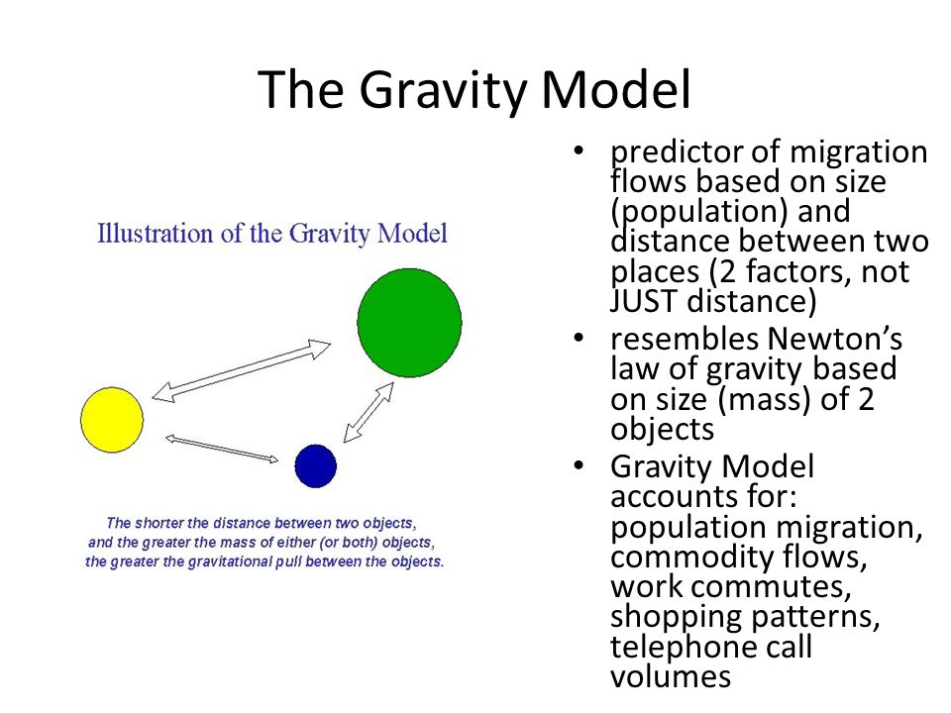

Thomas Malthus’ Population Theory
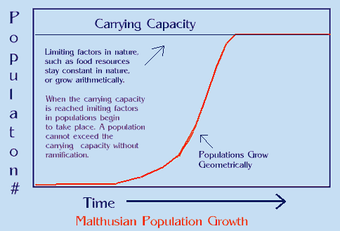

Malthus on Overpopulation
- British economist Thomas Malthus (1766-1834) was one of the first to argue that the world’s population was increasing much faster than the food supply.

Gave a dystopian view of the future (1798); food production increases arithmetically, whereas human reproduction increases geometrically (doubling each generation); despite checks on population (e.g., plague, famine) there would continue to be starvation.

- Neo-Malthusians build on Malthus’ theories today, arguing that the gap between population growth and resources is wider than Malthus anticipated (due to a number of factors) and the world population is outstripping a variety of resources including food, water, and energy.

Problems with Malthus’ Theory
- resources are not fixed
- a growing population is not all bad, more people could stimulate the economy & produce more food
- more people means more brain power to invent ways to improve life
- Conditions over the past 50 yrs have not supported Malthus, he was fairly close on food production, but wrong on the population growth
- he did not account for improved growing techniques and crops or the trend of Population Pyramids

Unit 3- Cultural Geography

Distribution of World Religions
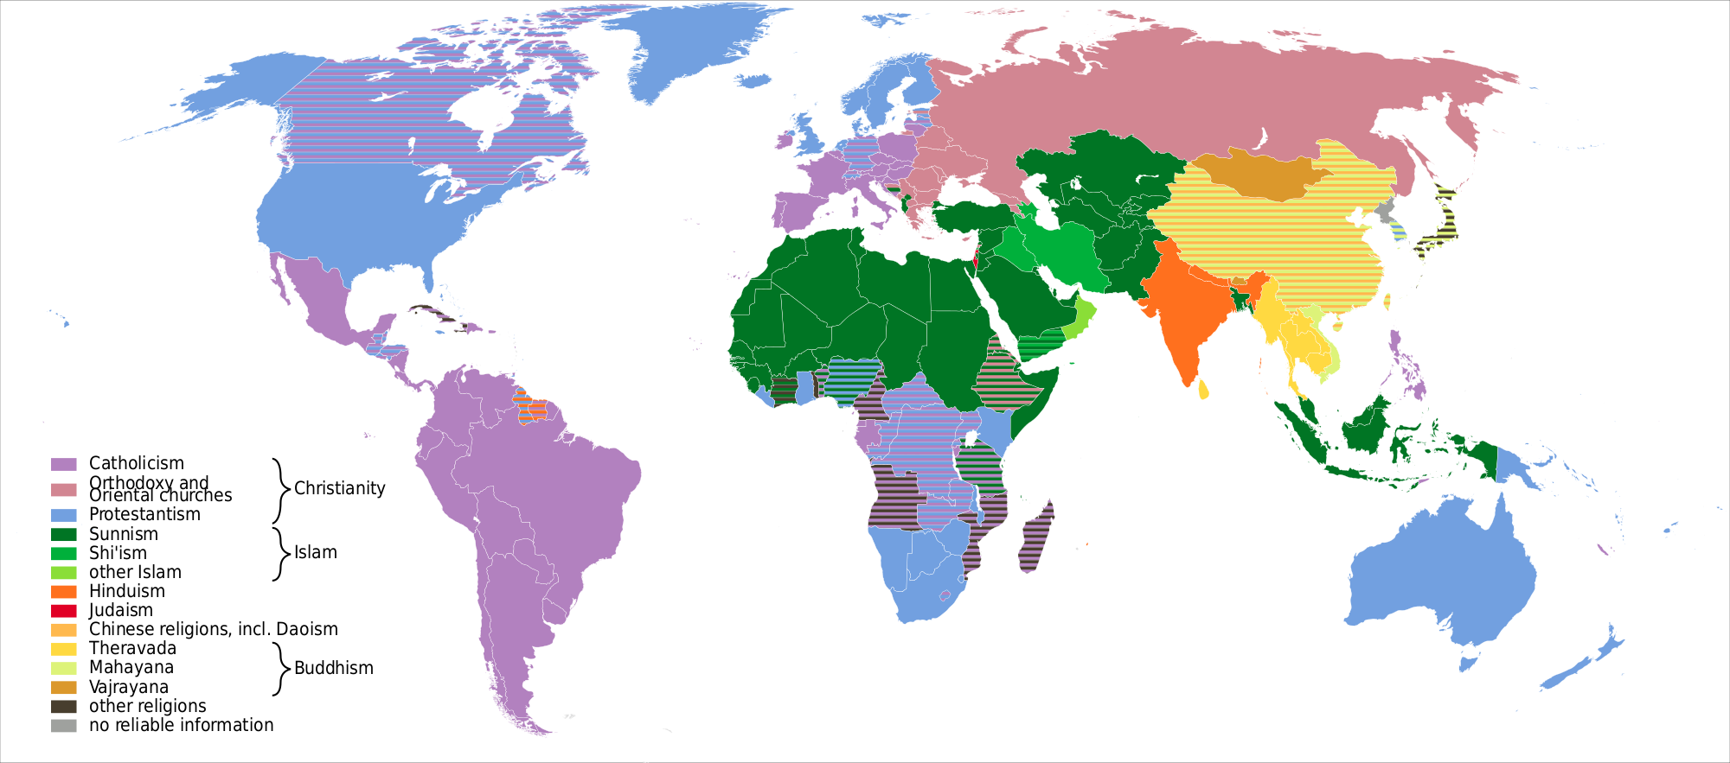

https://upload.wikimedia.org/wikipedia/commons/thumb/1/1f/World_religions_map_en.svg/2000px-World_religions_map_en.svg.png

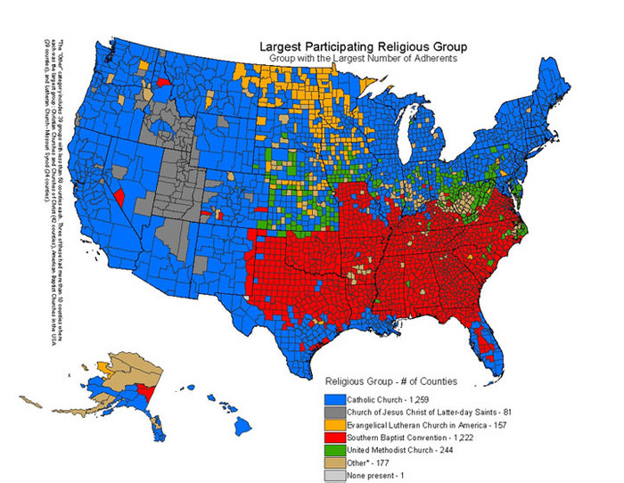

Theories on the Origin and Diffusion of Languages

There are two theories about the origin and diffusion of Indo-European. The Nomadic Warrior Thesis of Kurgan origin states that the first Indo-European speakers were Kurgans who lived near present-day Russia and Kazakhstan. They migrated westward into Europe, southward to Iran and South Asia, and eastward into Siberia, largely by military conquest.
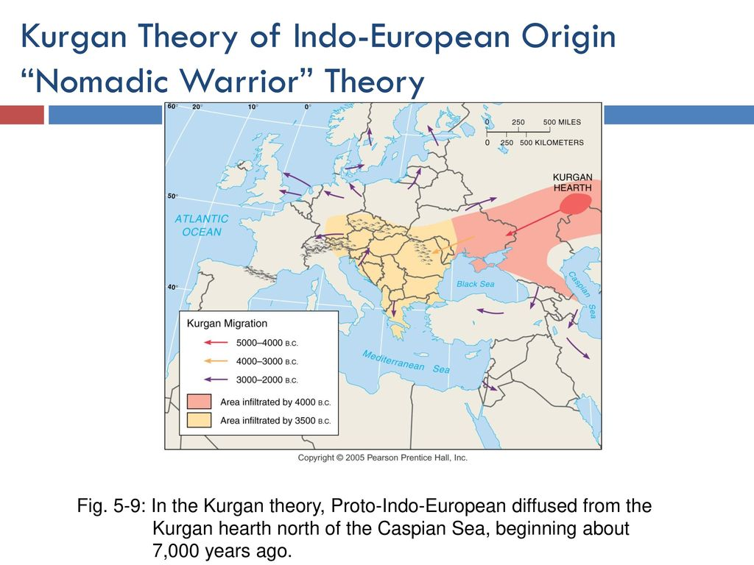

Anatolian Theory origin states that the first speakers of Proto-Indo-European lived in eastern Anatolia two thousand years before the Kurgans, and that they migrated west into Europe and east into Asia with their agricultural practices, rather than by military conquest. Regardless of how Indo-European diffused, communication was poor and the result was isolation.

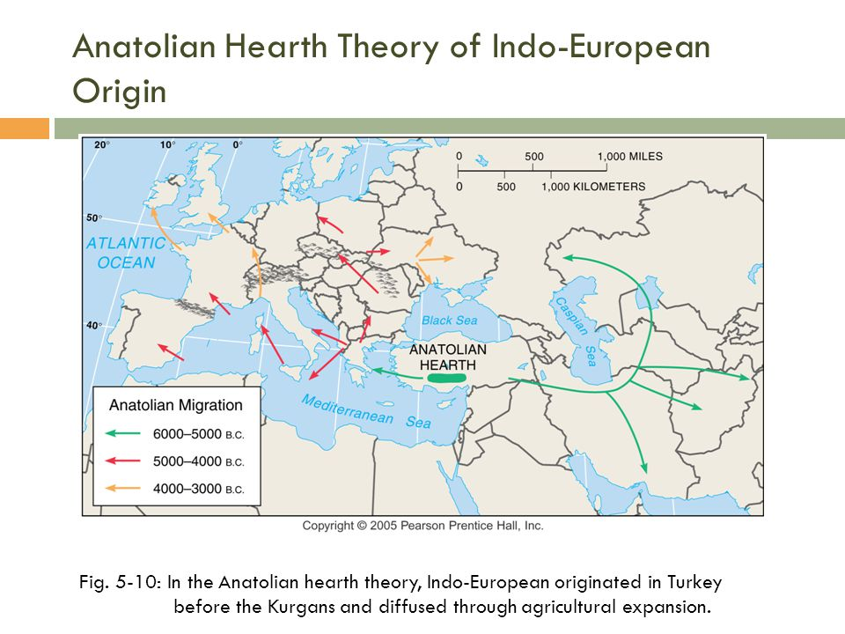

Indo-European Language Tree & Distribution

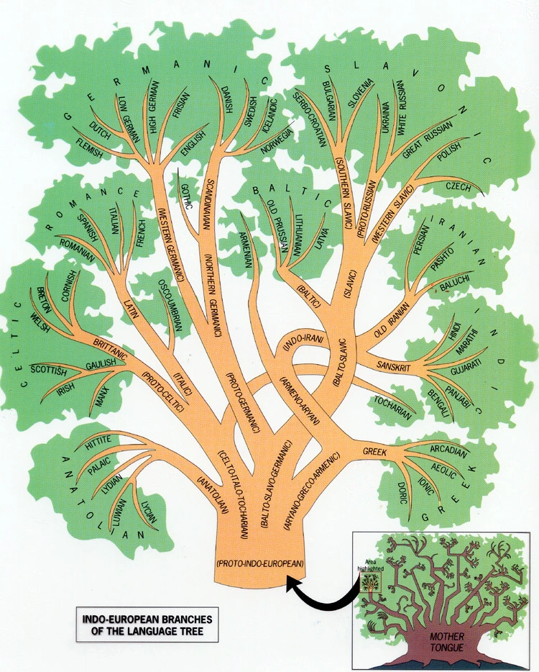

https://anthropologynet.files.wordpress.com/2008/02/indoeuropean-language-family-tree.jpg?w=750

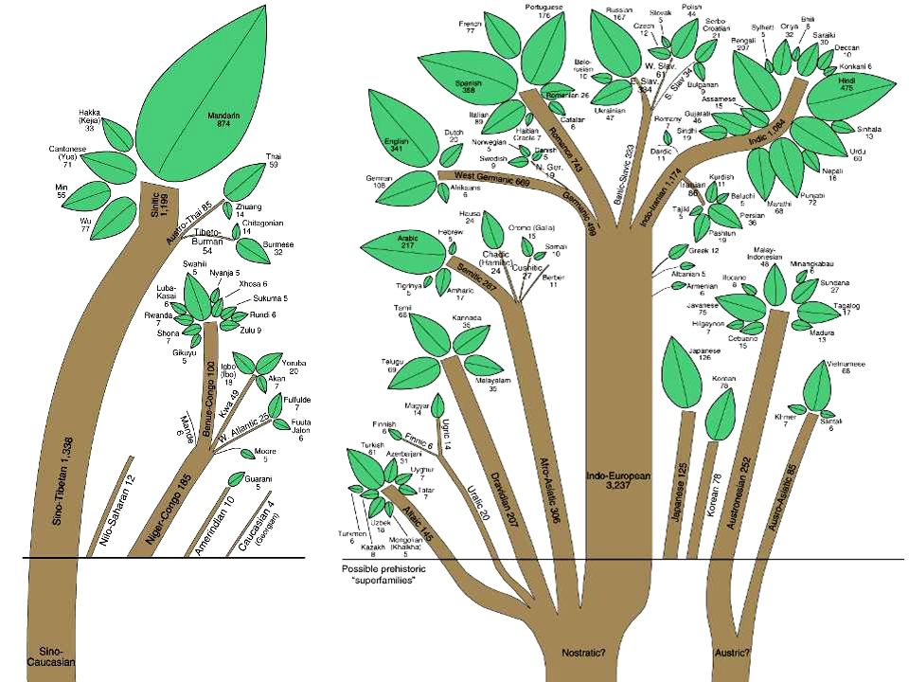

https://images.slideplayer.com/13/3915691/slides/slide_41.jpg

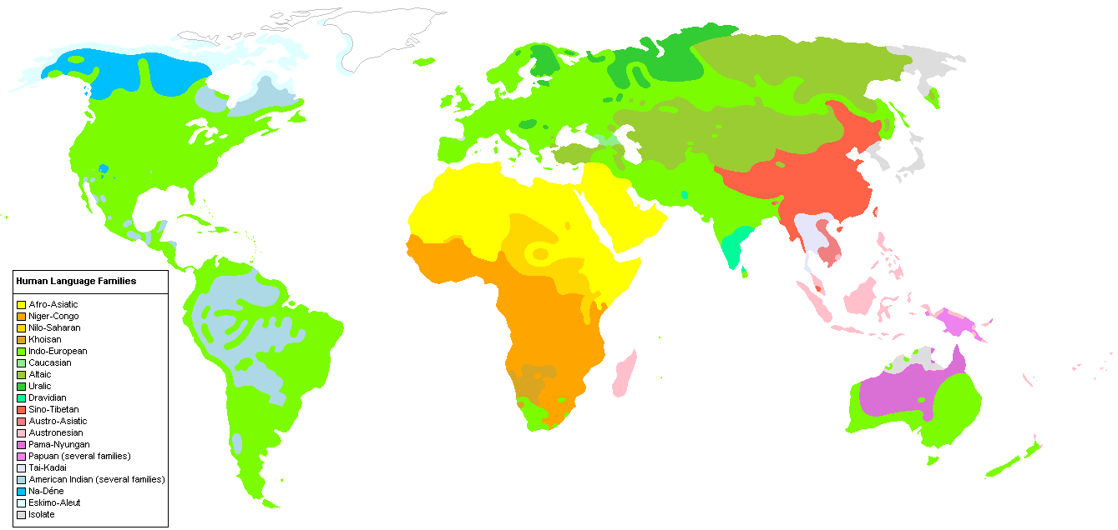

https://upload.wikimedia.org/wikipedia/en/8/8c/Human_Language_Families_Map_%28Wikipedia_Colors_.PNG

Unit 4- Political Geography

Theories for the Development of the Nation-State

Organic Theory (Friedrich Ratzel)- states that did not expand their land area would disintegrate like an organism that fails to find food

Heartland Theory (Sir Halford Mackinder)- says that the Eurasian landmass was the world’s heartland and thus the key to world domination, the resource-rich, land-based “pivot area” (Heartland) would be key to world dominance (controlled by the USSR at that time; diametrically opposed to Mahan’s contention of sea power;
"Who rules East Europe commands the Heartland;
Who rules the Heartland commands the World-Island;
Who rules the World-Island controls the world."

Rimland Theory (Nicholas Spykman)- says that the area surrounding the heartland including the oceans was the key to world political power, the Eurasian Rimland, not the Heartland would be key to global power; Britain, US and USSR would be the main power players;
Who controls the Rimland rules Eurasia;
Who rules Eurasia controls the destinies of the world.
*Spykman is known as the “godfather of containment”

Heartland (MacKinder) and Rimland (Spykman) Theories

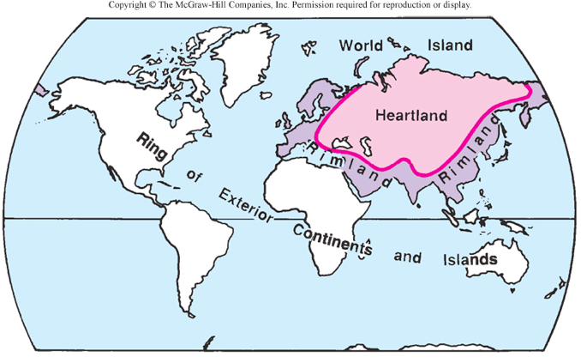

Enclaves & Exclaves
An Enclave is a territory, or a part of a territory, that is entirely surrounded by the territory of one other state.

An Exclave is a portion of a state or territory geographically separated from the main part by surrounding alien territory (of one or more states)

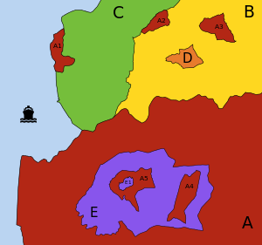

Shapes of States

Compact: Poland
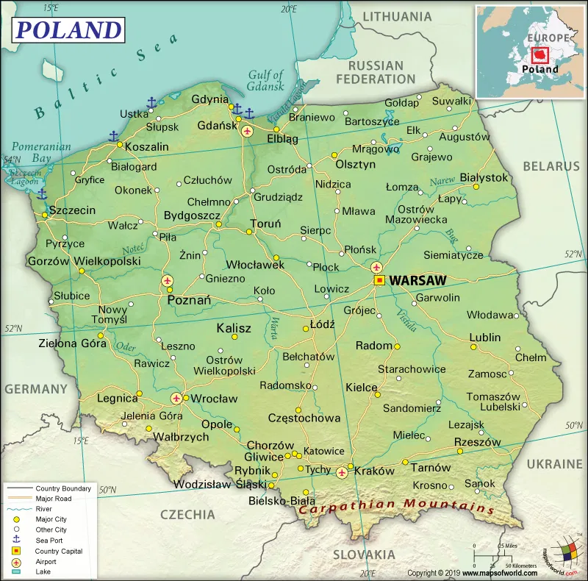

Elongated: Chile
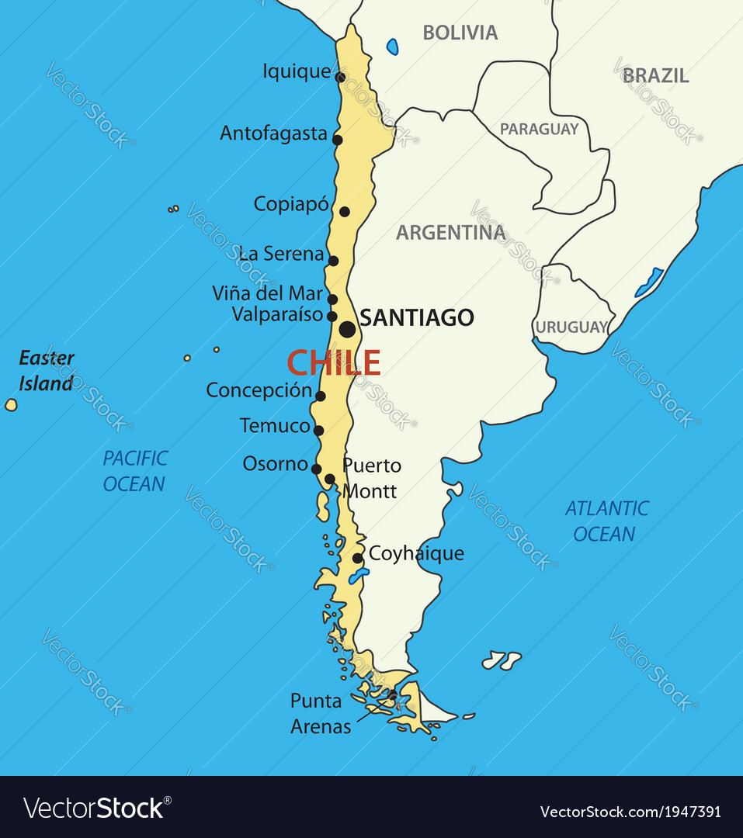

Prorupted: Thailand
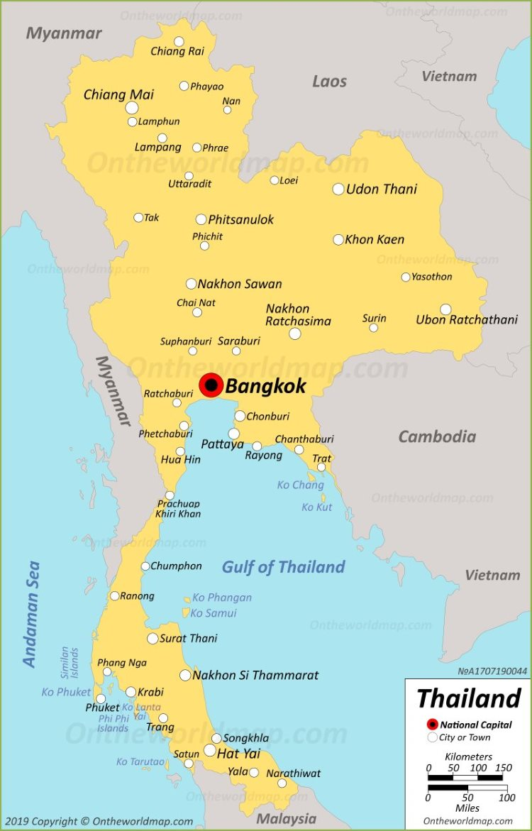

Perforated: South Africa
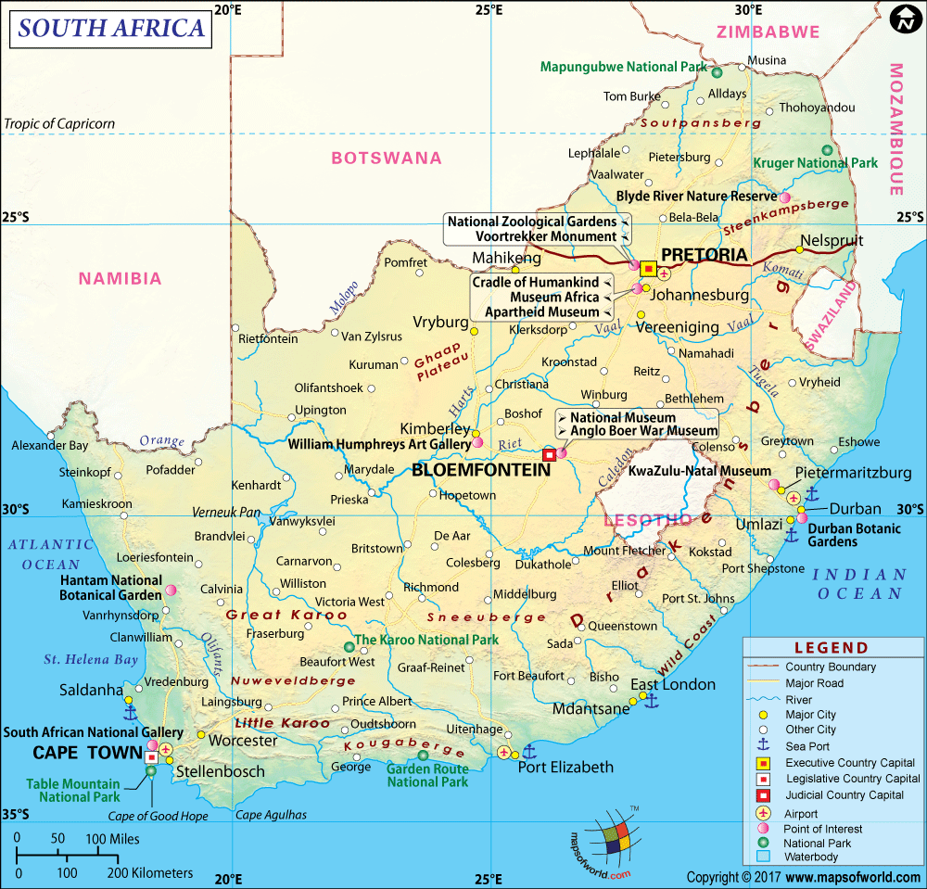

Fragmented: Indonesia

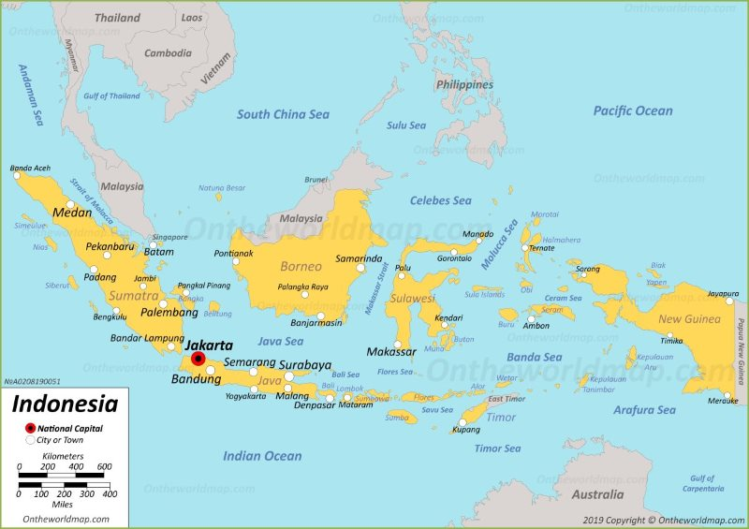

Unit 5- Agricultural Geography

Vegetative Hearths
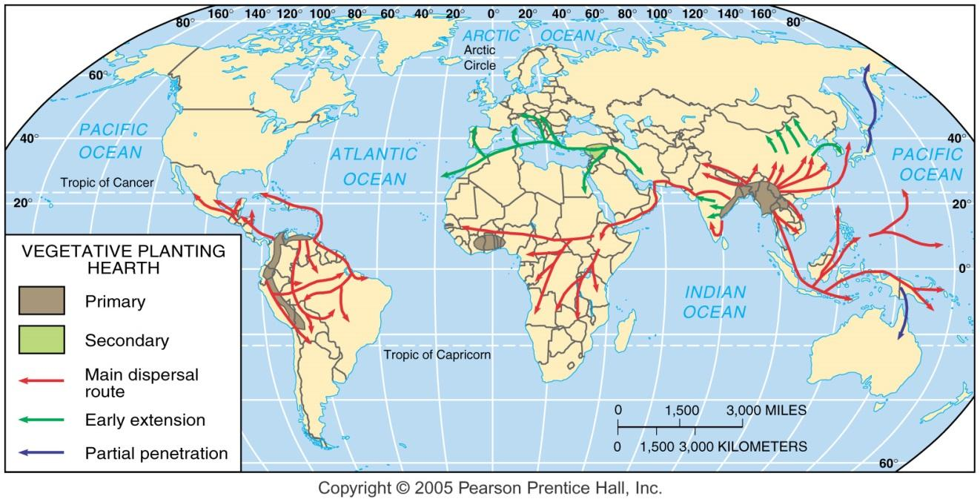

Seed Hearths
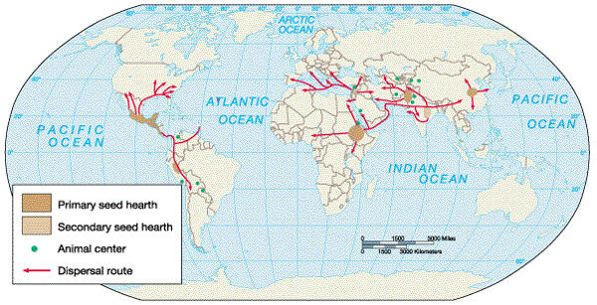

Carl Sauer: 11 Areas of Agriculture Innovations

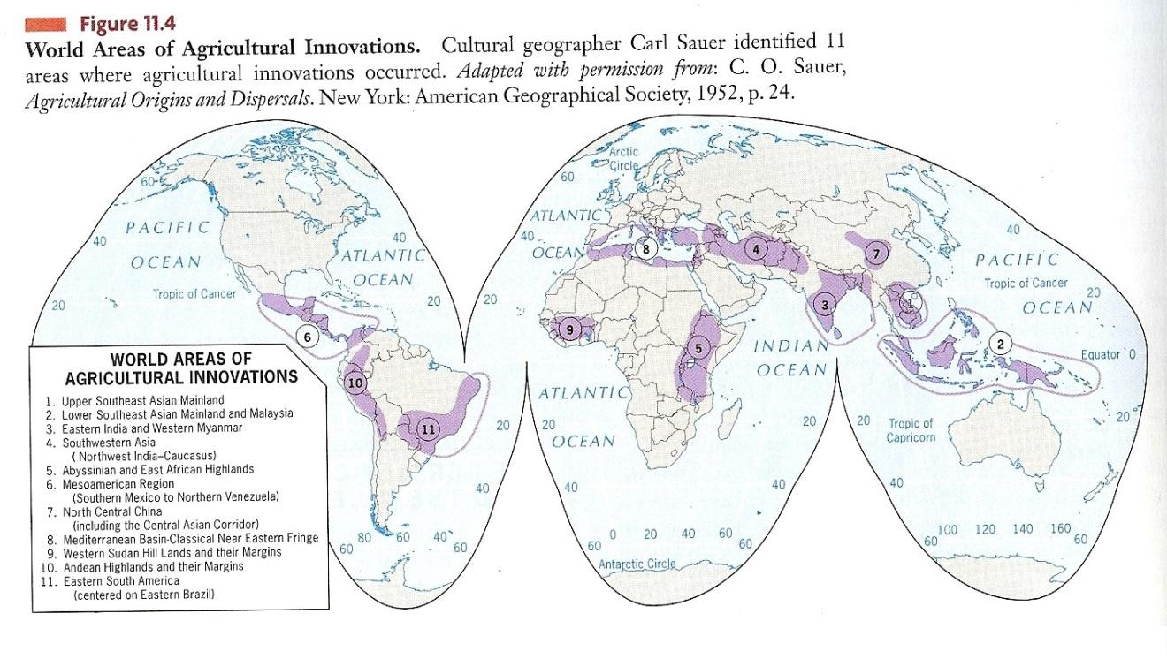

Derwent Whittlesey’s Agricultural Regions Map

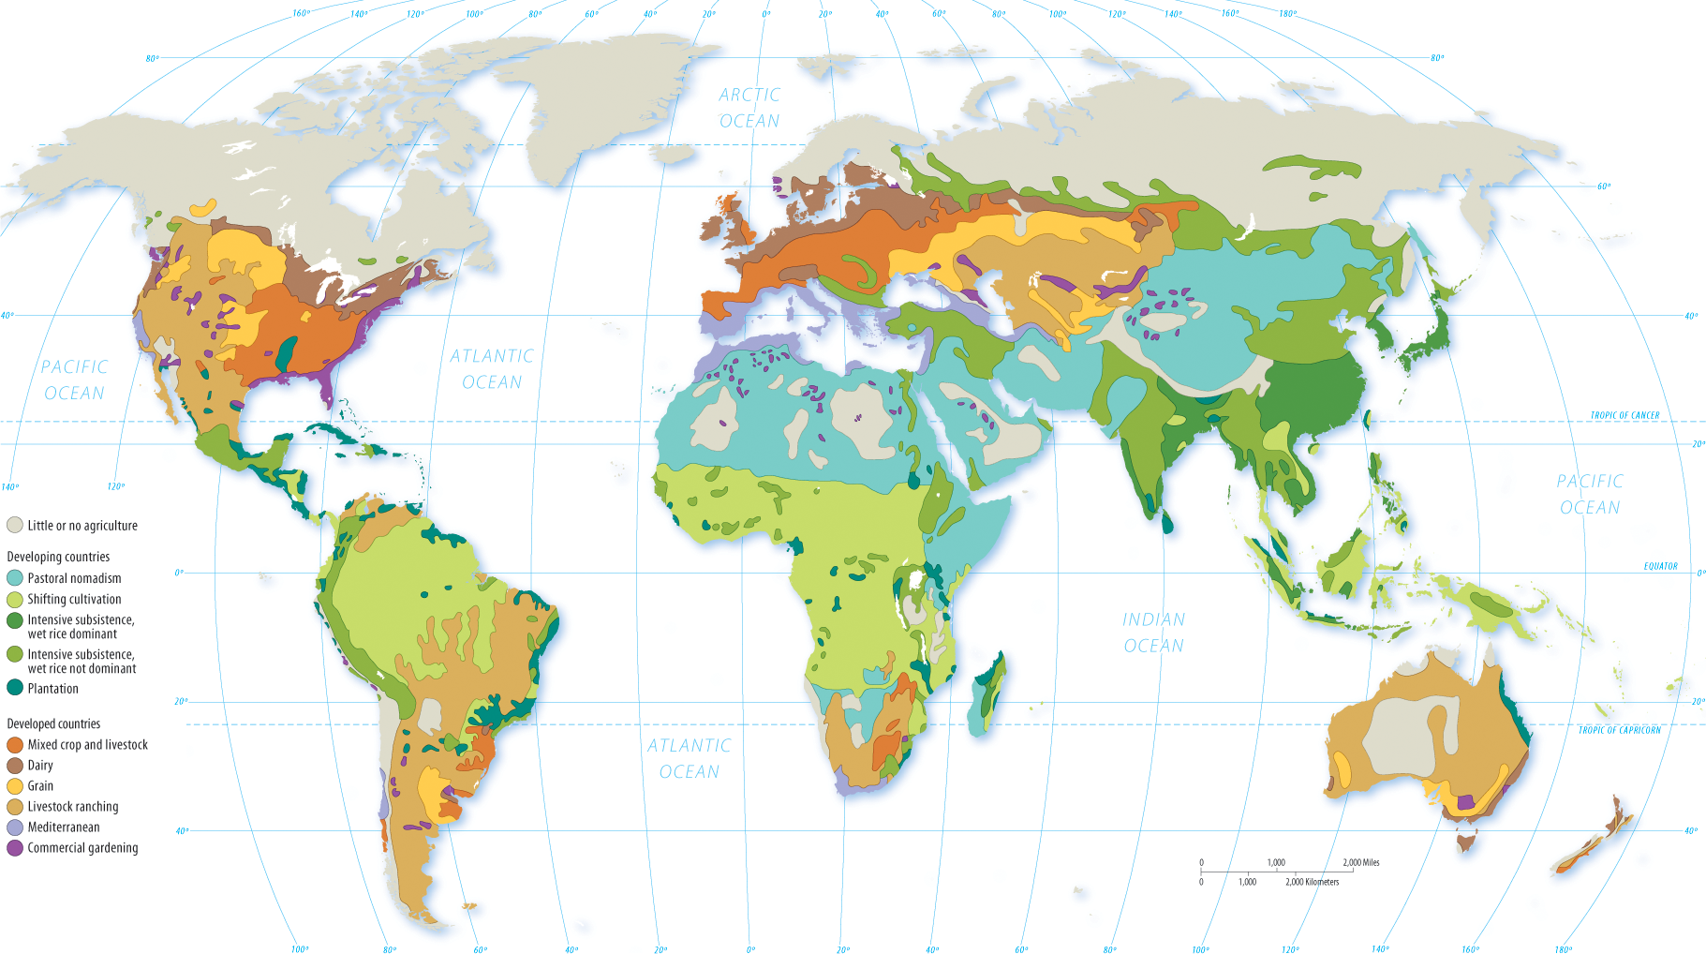

Von Thunen's Agricultural Model
Johann Heinrich von Thunen (Isolated State) (1826): Discussed agricultural location as primarily a factor of transportation cost and profit maximization by farmers through his model. For the image to the left - the black dot represents a city; 1 (white) dairy and market gardening; 2 (green) forest for fuel and building materials; 3 (yellow) grains and field crops; 4 (red) ranching; the outer, dark green area represents wilderness where agriculture is not profitable.

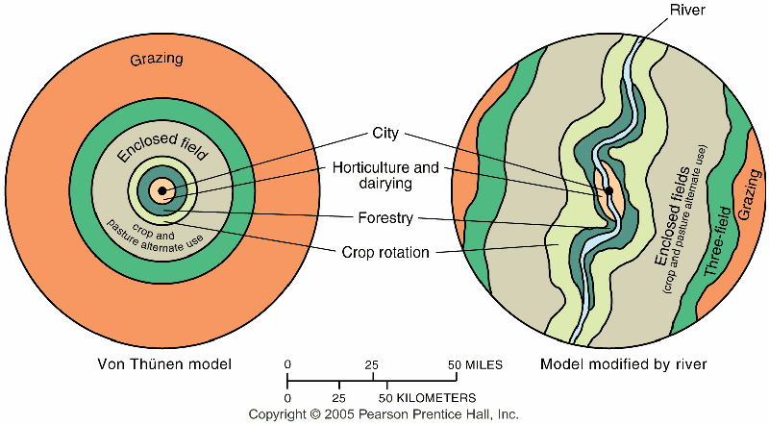

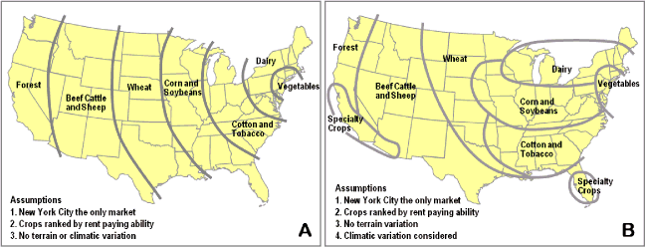

Esther Boserup’ Theory
In 1965, Boserup discussed that population growth stimulates intensification in agricultural development (stimulates technology) … rather than being increased by agricultural output (Malthus upside-down); the rate of food supply may vary but never reaches its carrying capacity because as it approaches the threshold, an invention or development increases food supply, however, the depletion of nutrients creates diminishing returns.

Farmers who have traditionally practiced subsistence farming are pressured to grow food for export instead of direct consumption due to the adoption of the international trade.
The problem is that more land is being used to farm export crops and more people are moving away from subsistence farming so many developing countries face food shortages.

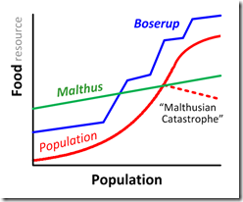

Unit 7- Industrial & Economic Geography

Five Sectors of the Economy
Primary Sector “Grow It” The primary sector of the economy extracts or harvests products from the earth. Activities associated with the primary sector include agriculture (both subsistence and commercial), mining, forestry, farming, grazing, hunting and gathering, fishing, and quarrying.
Secondary Sector “Make It” The secondary sector of the economy manufactures finished goods. Activities associated with the secondary sector include metal working and smelting, automobile production, textile production, chemical and engineering industries, aerospace manufacturing, energy utilities, engineering, breweries and bottlers, construction, and shipbuilding.
Tertiary Sector “Sell It” The tertiary sector of the economy is the service industry. Activities associated with this sector include retail and wholesale sales, transportation and distribution, entertainment (movies, television, radio, music, theater, etc.), restaurants, clerical services, media, tourism, insurance, banking, healthcare, and law. *In the U.S., more than 80% of the labor force are tertiary workers.
Quaternary Sector “Develop It” The quaternary sector of the economy consists of intellectual activities. Activities associated with this sector include government, culture, libraries, scientific research, education, and information technology.
Quinary Sector “Manage It” The Quinary sector includes the highest levels of decision making in a society or economy. This sector would include the top executives or officials in such fields as government, science, universities, nonprofit, healthcare, culture, and the media.

Economic Location Theories

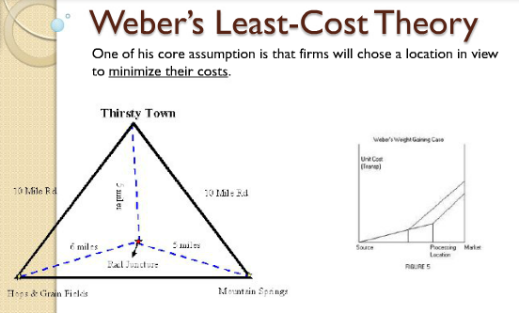
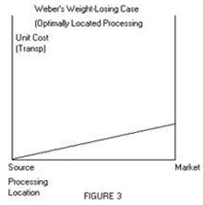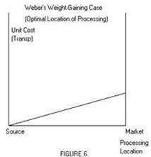

Least Cost Theory (1940s): owners of manufacturing plants seek to minimize three costs: 1) transportation, 2) labor, and 3) agglomeration (too much can lead to high rents & wages, circulation problems – and ultimately to deglomeration); in the weight-losing case, firms locate closer to the raw materials to reduce cost; in the weight-gaining case, firms locate closer to the market.

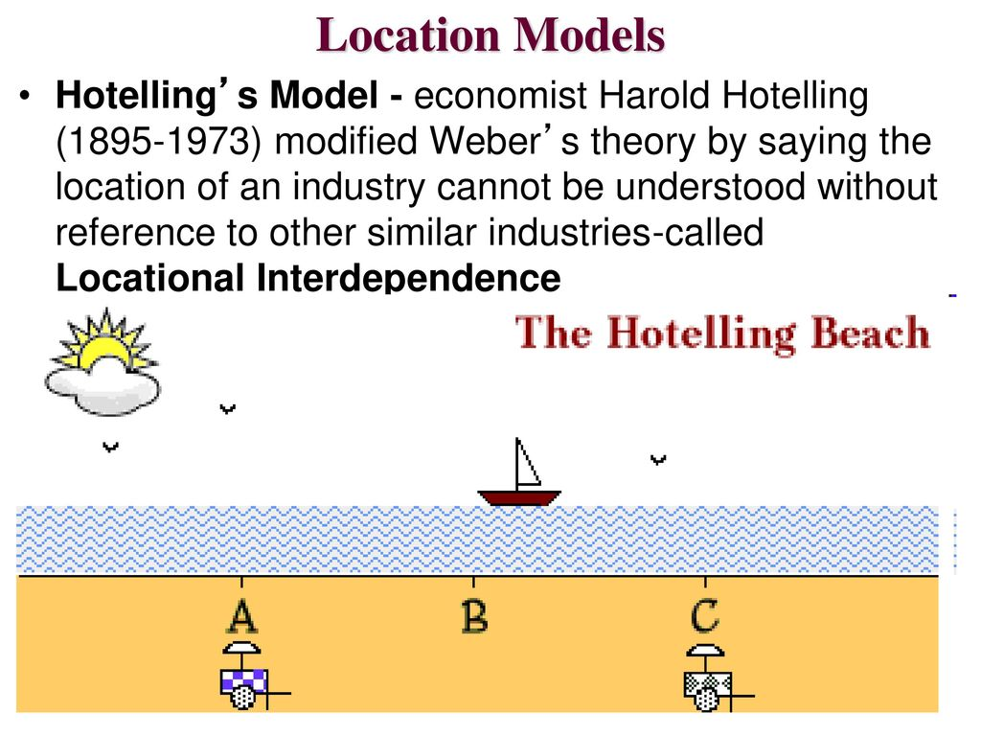
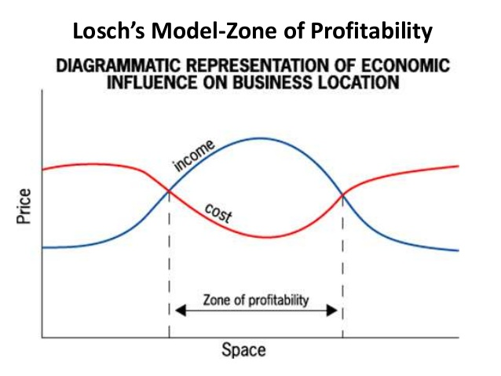

Immanuel Wallerstein’s World Systems Theory (Core Periphery Model)

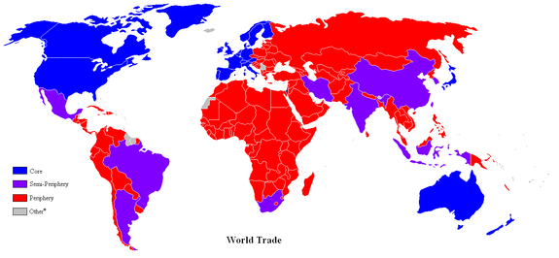
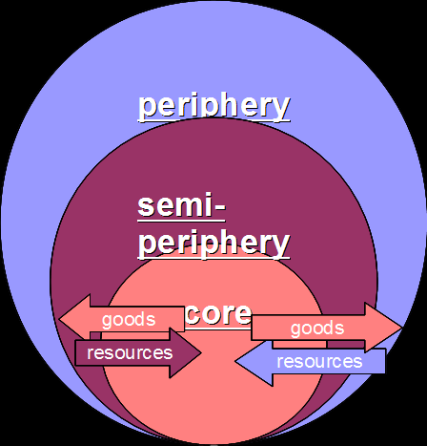
World Systems Theory (1974-89): proposed a three-tier structure to a “one-world” economic and political structure; the "core" (industrialized capitalist countries – US, UK, Japan) dominates other countries; the "semi-periphery" (industrializing – Brazil, China, India) as the countries which are dominated (usually by the core) while at the same time dominating others (usually in the periphery); and "periphery" (undeveloped or developing – Congo, Zambia, Haiti) are dominated since they are often dependent on the more powerful countries.

Rostow’s Modernization Model
(Ladder of Development)

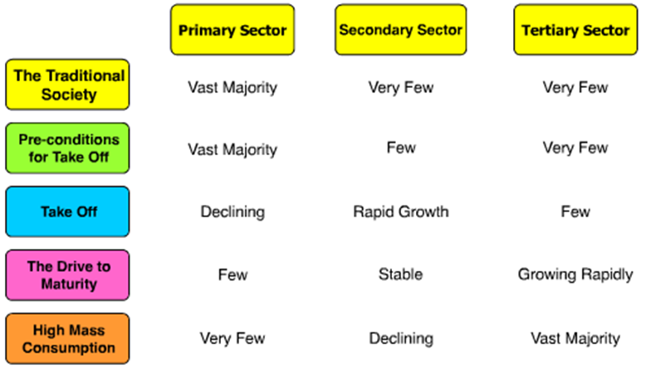
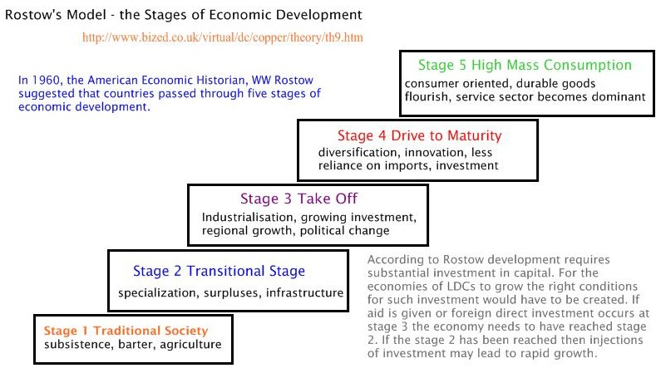

Unit 7: Urban Geography

Rank Size Rule v Primate City Rule
When cities are rank-ordered from largest to smallest, the "rank-size rule" says that the r-th largest will be 1/r-th the size of the largest city, i.e., rank-times-size is a constant equal to the size of the largest city.

http://www.slideshare.net/PlanningTheory/primate-city-and-rank-size-rule

Central Place Theory (Walter Christaller)

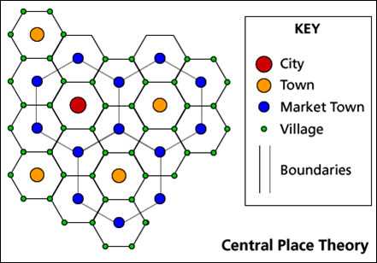
The theory is designed to explain the spatial distribution of human settlements. Central places are settlements providing services to their surrounding “market areas”. The ordering of settlements based on the number and level of services they provide produces a hierarchy. Like the left-hand diagram, hierarchies are often complicated because market areas of different-order settlements overlap (shown as solid and broken lines).

Bid-Rent Curve

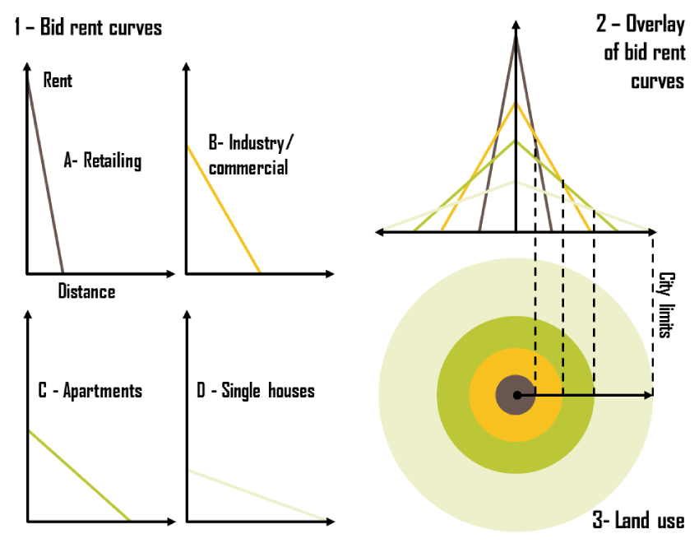
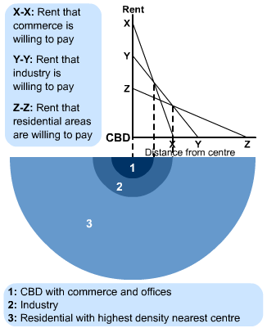

North American City Models
Concentric Zone Model

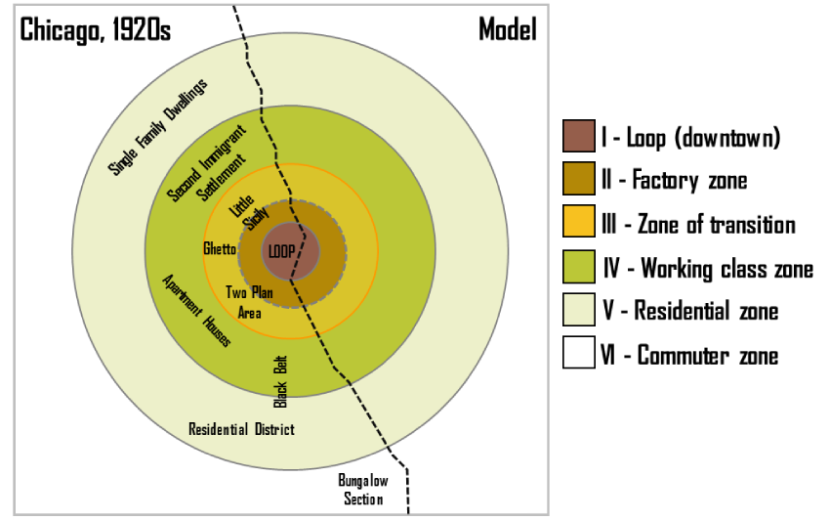

- (1925): structural model of the American central city (based on Chicago in the 1920s); the zones identified are
1) the CBD
2) the transition zone of mixed residential, factory, and commercial use;
3) low-class residential homes (inner city);
4) better quality middle-class homes; and
5) upper-class commuters zone. Burgess's work is based on bid rent … the amount that people will pay for the land (e.g., wealthier families tended to live much further away from the CBD; could afford automobiles)

Sector Model (Hoyt)

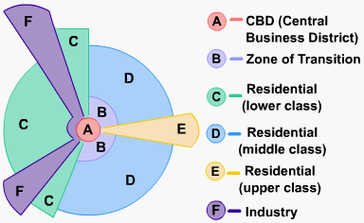
- (1939): improvements in transportation made the Burgess Model more obsolete. Hoyt observed that zones expanded outward from the city center along electric trolley lines, railroads, highways, and other transportation arteries; wedge-shaped patterns -- or sectors -- emanating from the CBD and centered on major transportation routes.

Multiple Nuclei Model (Harris & Ullman)

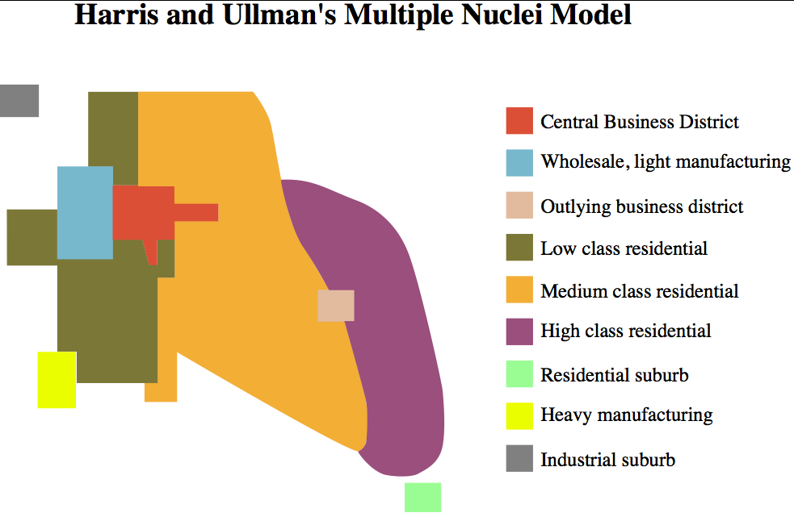
- (1945): based on the idea that people have greater movement due to increased car ownership. This increase of movement reduced the primacy of the CBD and allowed for the specialization of regional centers (e.g., nuclei such as light manufacturing or business parks).

Global Urban Models

Latin American (Griffin-Ford)

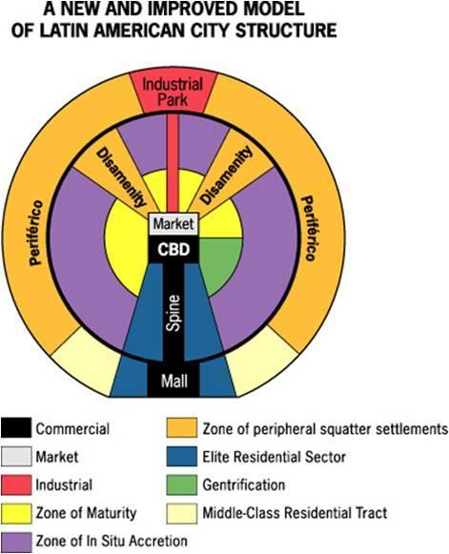

African City Model (De Blij)

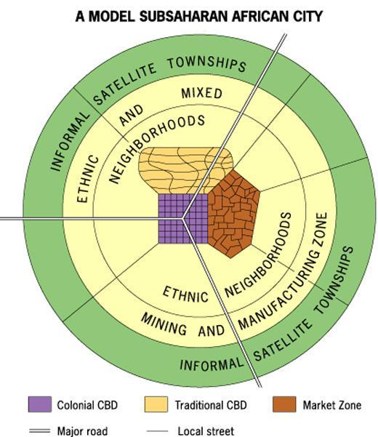

Southeast Asian City Model (McGee)

