AP Human Geography Name __________________
Date __________________ Period __________________

Unit 3: Cultural Patterns & Process
Culture Project
In groups of four, your task will be to learn about your assigned region and design a presentation that introduces everyone to the unique and interesting aspects of the various cultures throughout your region. This is primarily a visual presentation. The images must be the focus of the presentation! Be sure to highlight the important and interesting aspects of your regions’ culture through images that show how the regions’ cultures have created and impacted the cultural landscape.

Your presentation will be in the form of a Google Site. You will begin by conducting research about the various cultures & ethnic groups in the region in order to better understand the people and countries of that region. Areas of culture will include; Food & Drink, Customs & Traditions, Clothing, Religion, Holidays/Festivals, Language, Art, Sports & Games, Music & Entertainment, Tourist Attractions & Landmarks, Housing & Architecture, Historical Events. You must include specific & unique folk and/or popular cultural examples for each of these categories. Each example must include a description and a picture. You may also include videos and audio clips. More specific information about what to include in each category is listed below.

Keep in mind that you will not be presenting all of the information in your project to the class. Each person will choose one example from each of their three categories and will be limited to 1:30-2:00 minutes.

Food & Drink: 4 examples of important/unique foods and drinks
Customs & Traditions: 4 examples of important/unique social customs
Clothing: 4 examples of traditional and popular clothing for men and women (2 for each)
Religion: 4 examples of popular and/or folk religions (clerics, symbols, buildings, temples, statues, shrines, ceremonies, rituals, etc.)
Holidays/Festivals: 4 examples of non-religious Holidays and/or Festivals
Language: 4 examples of languages spoken in your region (Not English!) (video/audio of native speakers, alphabet, signs, words, phrases, slogans, advertising, etc.)
Art: 4 examples of unique pieces of artwork (paintings, drawings, sculpture, etc.)
Sports & Games: 4 examples of unique sports and/or games played in the region
Music & Entertainment: 4 examples of folk/pop music and other forms of entertainment such as TV shows, Internet Videos, Movies, Leisure activities etc.)
Tourist Attractions/Landmarks: 4 examples of important/unique natural and/or man made tourist attractions
Housing & Architecture: 4 examples of folk/pop housing and building styles (2 of each)
Historical Events: 4 examples of major historical events had a specific impact on the culture/ cultural landscape of your region

Cultural Regions
Latin American (Mexico, Central America, South America and the Caribbean)
European (All Countries in Europe excluding those in the Slavic region)
Slavic (Russia, Belarus, Ukraine, Czech Republic, Slovakia, Bosnia & Herzegovina, Bulgaria, Croatia, Macedonia, Montenegro, Serbia, and Slovenia)
Islamic (Southwest Asia and North Africa)
Sub Saharan Africa (All of Africa south of the Sahara Desert)
Sino-Japanese (Japan, North & South Korea, China, Tibet, Taiwan, Mongolia)
Indic (India, Bangladesh, Sri Lanka, Nepal, Bhutan)
South East Asia (All countries to the southeast of China and including Indonesia and the Philippines)
Austral/Insular Oceanic (Australia, New Zealand, Papua New Guinea, Tonga, Palau, Samoa, Fiji, Micronesia, French Polynesia, Kiribati, Nauru, Tuvalu, Vanuatu)

Cultural Regions Map

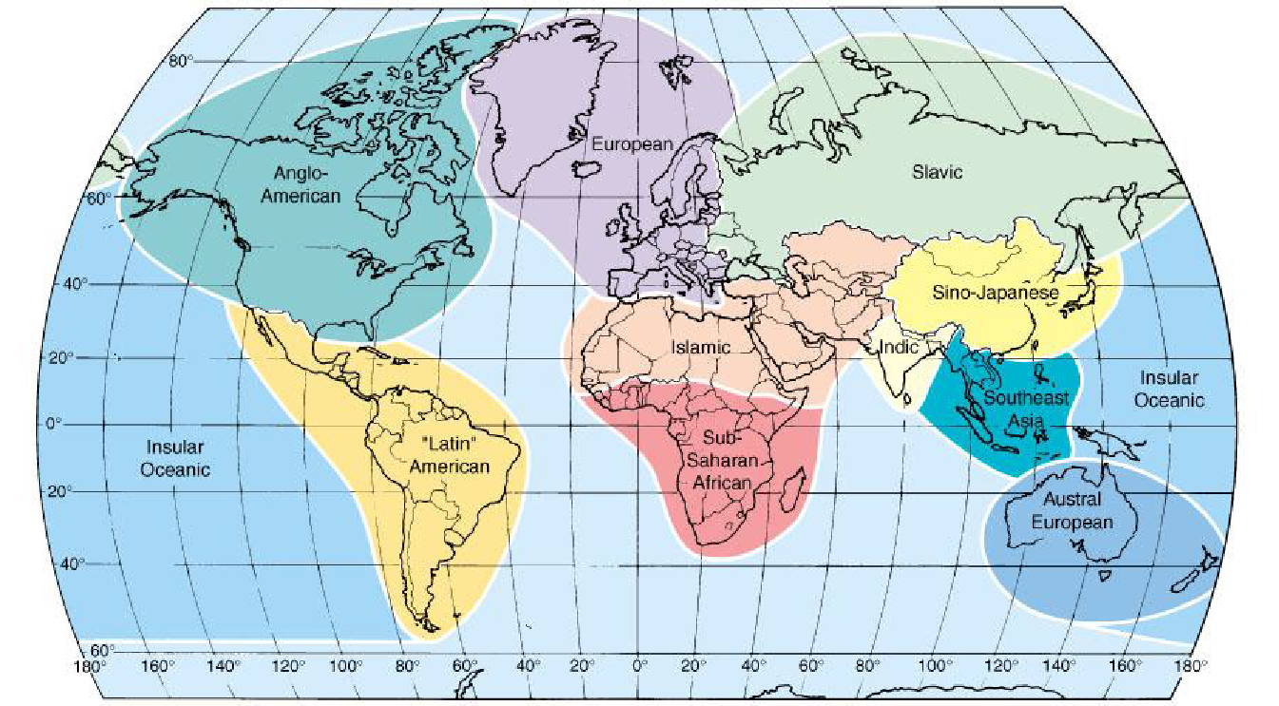

Mr. Flohr Name __________________
Middle Creek High School Date __________________ Period _________________

Culture Project Rubric

(4) Distinguished |  | (3) Accomplished | (2) Proficient | (1) Unsatisfactory
Content
(4) 70 | A complete understanding of the material is evident and the information in all aspects of the project is correct, complete, and contains abundant detail. All sources are cited correctly in MLA format.
(3) 60 | A strong understanding of the material is evident and the information in all aspects of the project is correct, complete, and is sufficiently detailed. Some sources may be cited incorrectly or missing.
(2) 50 | A moderate understanding of the material is evident and the information is mostly correct. Some aspects may be incomplete or missing and/or lacking detail. Some sources may be cited incorrectly or missing.
(1) 40 | A weak understanding of the material is evident. The information is incorrect, there are major parts incomplete or missing, or the work is not completely original. Little to no detail is shown. Sources are not cited correctly, are incomplete, inadequate, or missing.
Organization/Visual
(4) 20 | The final product is very neat and professional with an excellent layout and organization. It is aesthetically pleasing, colorful and creative. The visual aids are clear, colorful, creative, and effectively support the information.
(3) 16 | The final product is neat and professional with a good layout and organization. It is attractive, colorful and creative. The visual aids are clear, creative and support the information.
(2) 12 | The final product is somewhat neat and the layout is somewhat organized. It is relatively attractive, colorful and creative. The visuals aids support the information to some degree.
(1) 8 | The final product is not neat or professional, and has little to no organization. It is not attractive, colorful or creative. The visual aids are not creative, don’t support the information, or are missing.
Presentation
(4) 10 | Holds attention of the audience with the use of direct eye contact, seldom refers to notes, speaks with inflection to maintain audience interest, emphasizes key points, demonstrates strong knowledge and enthusiasm about the topic during entire presentation
(3) 8 | Consistently uses eye contact with audience, refers to notes more frequently, speaks with satisfactory inflection, emphasizes key points, shows a good knowledge and enthusiasm about topic
(2) 6 | Makes inconsistent eye contact with audience, relies heavily on notes, speaks with little or no inflection, covers most key points, appears uncomfortable with information and is only somewhat enthusiastic about the topic
(1) 4 | Makes little to no eye contact with audience, reads the entire report from notes, speaks in a low monotonous tone which causes audience to disengage, does not have grasp of the information and shows little to no enthusiasm for the topic

Total Score

Content ____ + Organization ____ + Grammar ____ = ____ / _100_

